Create Database
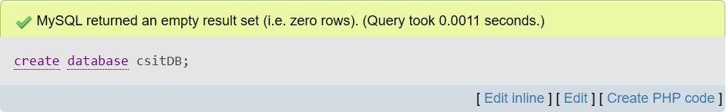
Consider the following relational table
- Student (s_id, s_name, addres, gender, age)
- Subject (Sub_id, sub_name, credit hours)
- Marks (s_id, sub_id, marks)
Create table Student
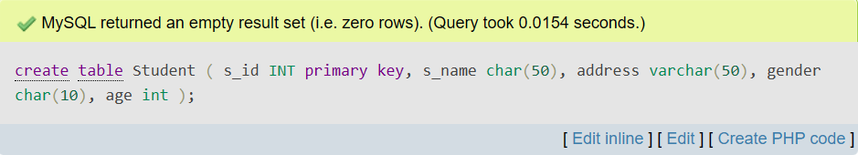
Create table Subject
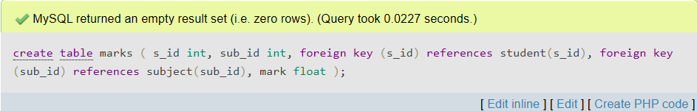
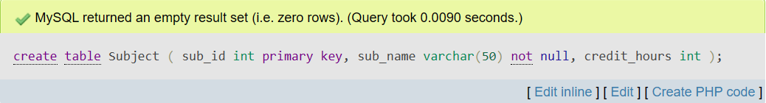Create table Marks

Describe Student
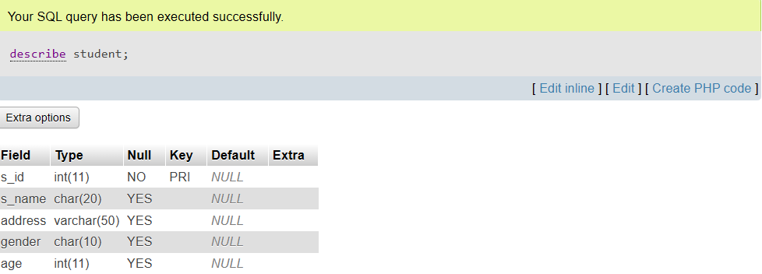
Insert Student
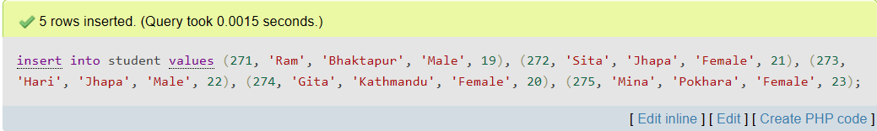
Display Student
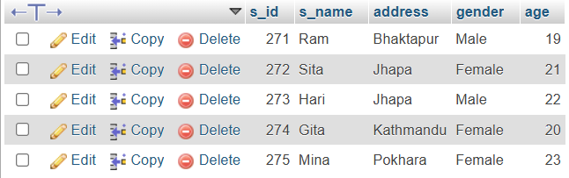

Describe Subject
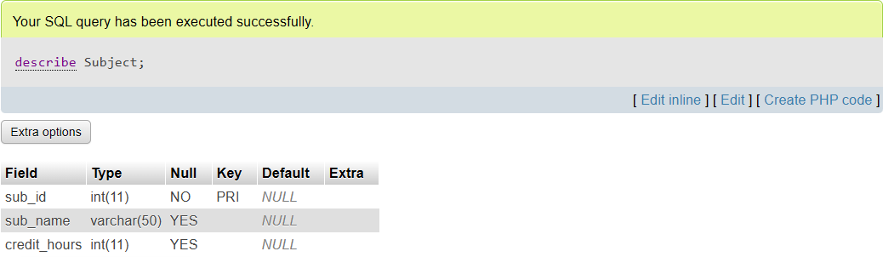
Insert Subject
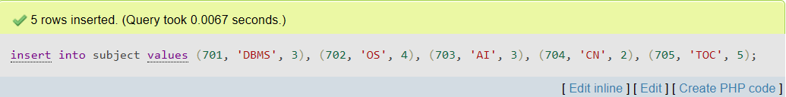
Display Subject
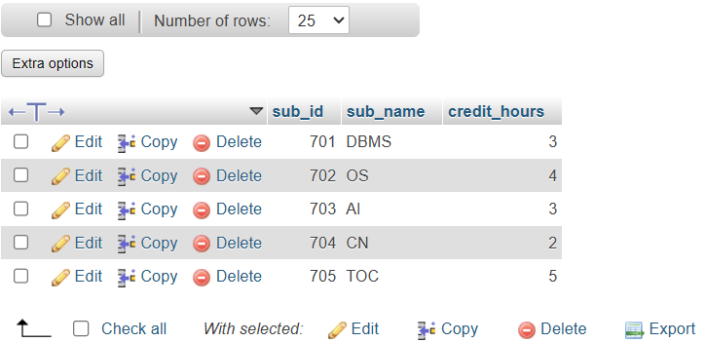

Describe Marks
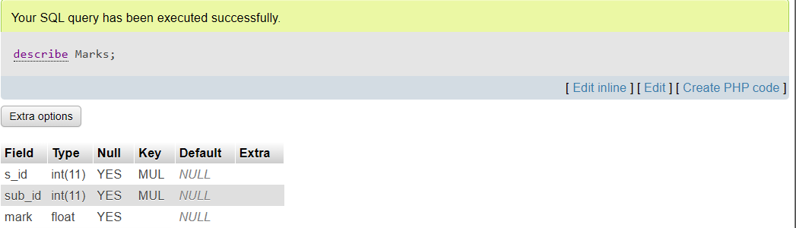
Insert Marks
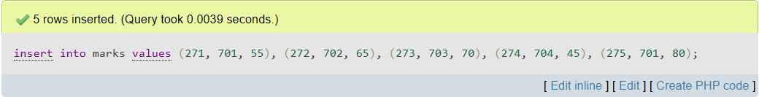
Display Marks
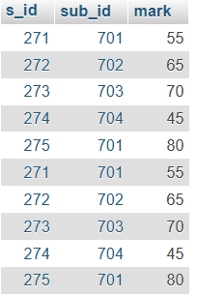

- Write SQL queries:
1. Display all students’ records.
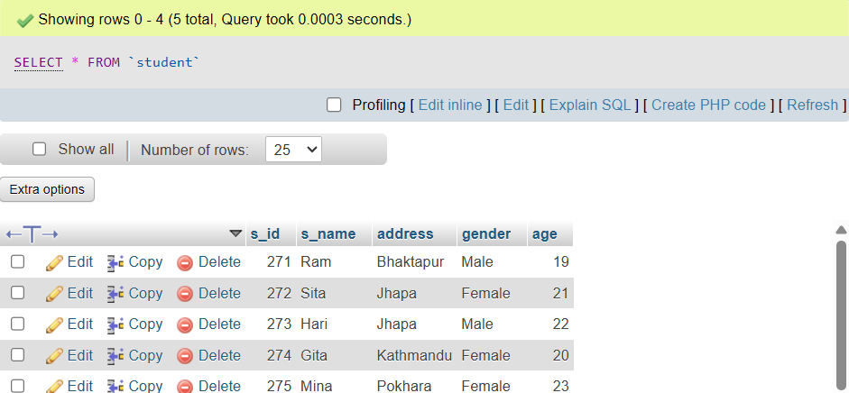

2. Display all students who are from bhaktapur.
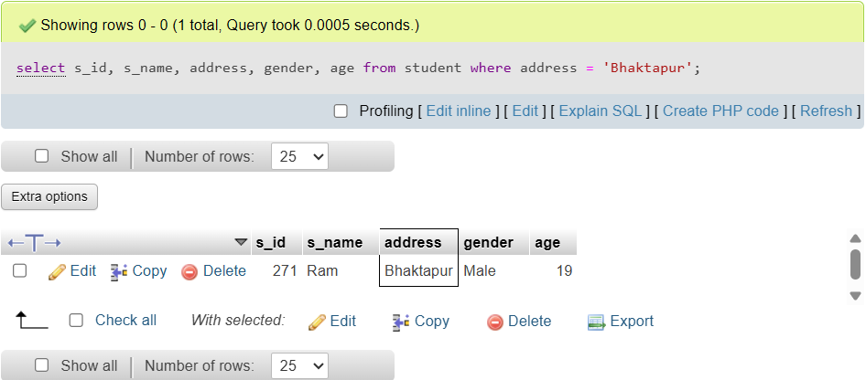

3. Display the name of students who is from jhapa and gender is male.
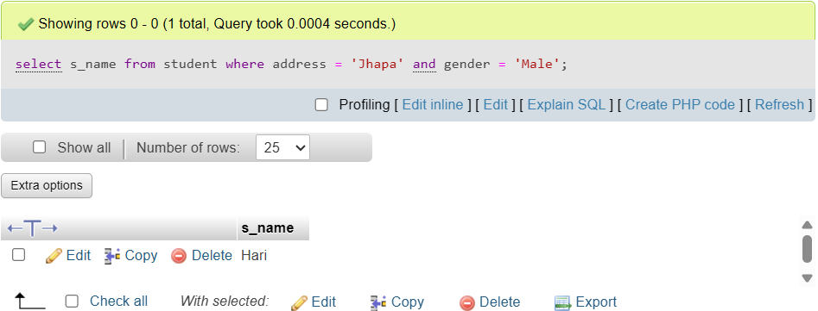
4. Display all subjects which credit hour is 3.
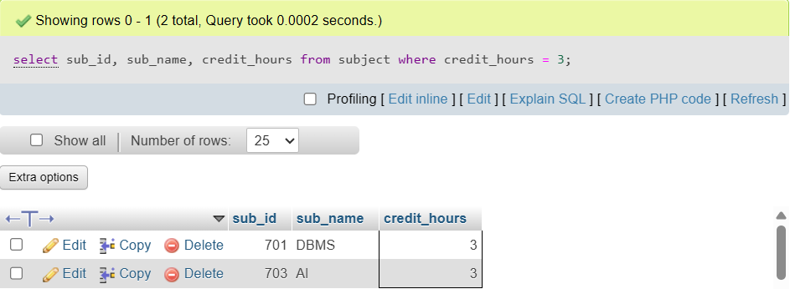
5. Display the student name and subject name whose age is greater than 20.


6. Display student name and marks who score more than 60%.
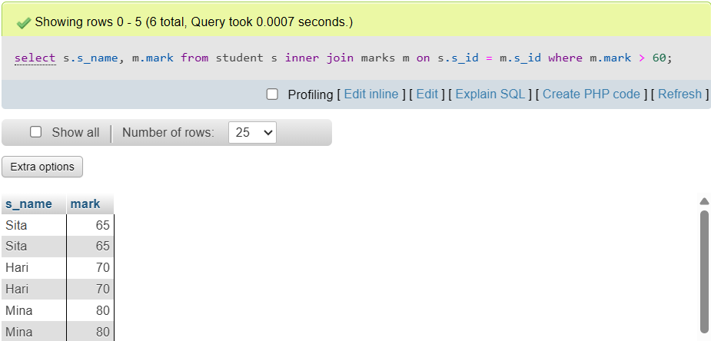

7. Find the name of student, subject name and marks who score 80% and gender is female.
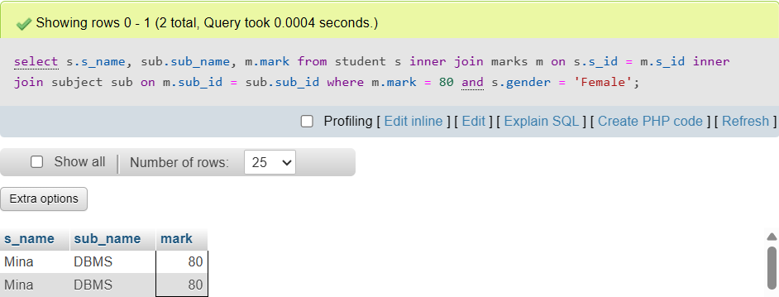

8. Display student id and subject id where student score 80 marks.
